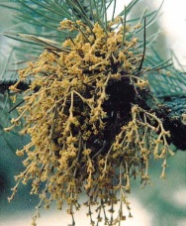
Dwarf Mistletoes
Very Low priority
Description
Lodgepole Pine Dwarf Mistletoe (Arceuthobium americanum) DMP
Western Hemlock Dwarf Mistletoe (Arceuthobium tsugense) DMH

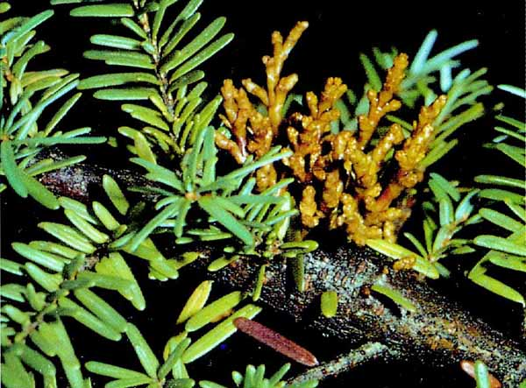
Dwarf mistletoes are parasitic plants. Infection produces either a localized or systemic infection. Infections cause swellings on branches and stems. Aerial shoots arise from these swellings and produce the flowers and seeds of this parasitic plant. When aerial shoots fall off they leave small, circular structures called basal cups, which persist on the host bark for years. Basal cups on fallen brooms are often the only evidence of dwarf mistletoe in older stands. Squirrel feeding may be associated with infected branches.

Both species of dwarf mistletoe cause widespread damage. Infections result in reduced growth, reduced wood quality and early death

Extent
Lodgepole pine dwarf mistletoe is currently a very low priority forest health factor in the district. It is possible that losses due to dwarf mistletoe could increase in the Bulkley TSA as MPB spreads and the incidences of small-patch harvesting increases. The losses resulting from Lodgepole pine dwarf mistletoe are accounted for in the current operational adjustment factors (OAF 1).

Western hemlock dwarf mistletoe has been found only in the western-most portion of the Kispiox TSA, in the Mill Lakes area. In other areas of the TSA, old gnarly branches on hemlock trees have sometimes been mistakenly identified as dwarf mistletoe. Hemlock dwarf mistletoe is widespread throughout the range of coastal western hemlock. The disease is not found in interior western hemlock stands. Heavily infected trees suffer reduced lumber recovery, reduced height and diameter growth, and occasional mortality.

Data

Tactics
- Management tactics should conform to those tactics outlined in the FPC Dwarf Mistletoe Guidebook.
http://www.for.gov.bc.ca/tasb/legsregs/fpc/fpcguide/dwarf/dwarftoc.htm
- In stands severely infested with dwarf mistletoe, avoid small-patch harvesting.
- If that cannot be avoided, openings should be planted with a combination of non-host species.

